BUNTS SANGHA’S
S.M. SHETTY COLLEGE OF SCIENCE, COMMERCE & MANAGEMENT STUDIES (AUTONOMOUS) POWAI,
MUMBAI - 400076


ON JOB TRAINING ( OJT )

SUBJECT: ON JOB TRAINING (OJT) EXPERIENCE REPORT

CLASS: M.Sc.I.T. – Part I (2025-26) SEMESTER: II SUBMITTED BY (Name): ADNAN CHOUDHARY
ROLL NUMBER: 20
SUBMITTED TO
DEPARTMENT OF INFORMATION TECHNOLOGY

Subject In-charge Coordinator External Examiner

For Partial Fulfilment for Degree of
Master of Science (Information Technology) in 2025-26

ACKNOWLEDGEMENT

I would like to express my sincere gratitude to my institute for providing me with the opportunity to undertake On Job Training (OJT) as a part of the M.Sc. IT Part-I Semester II curriculum. This opportunity has been instrumental in enhancing my practical knowledge and industry exposure.

I am highly thankful to Unified Mentor for giving me the opportunity to work as a Data Analyst Intern, where I gained valuable hands-on experience in a professional environment. This training helped me understand real-world data analysis processes, including data cleaning, visualization, and deriving meaningful insights for decision-making.

I would also like to express my heartfelt appreciation to my mentors and team members at Unified Mentor for their constant guidance, support, and encouragement throughout the training period. Their expert advice and constructive feedback significantly contributed to improving my analytical thinking and technical skills.
Furthermore, I extend my gratitude to my faculty coordinator and the institute for their continuous support and guidance during the successful completion of my OJT and this report.

Finally, I am thankful to everyone who directly or indirectly contributed to making this learning experience valuable and enriching.

INDEX

Sr. No. | Title | Page No.
1 | Internship Offer Letter | 1
2 | About Organization | 2
3 | OJT Undertaking | 3
4 | Monthly Report – January 2026 | 4
5 | Monthly Report – February 2026 | 5
6 | Monthly Report – March 2026 | 6
7 | Attendance Sheet | 7
8 | Completion Certificate | 8
9 | Student Feedback | 9
10 | Resume | 13

(Organization Letterhead)
INTERNSHIP OFFER LETTER
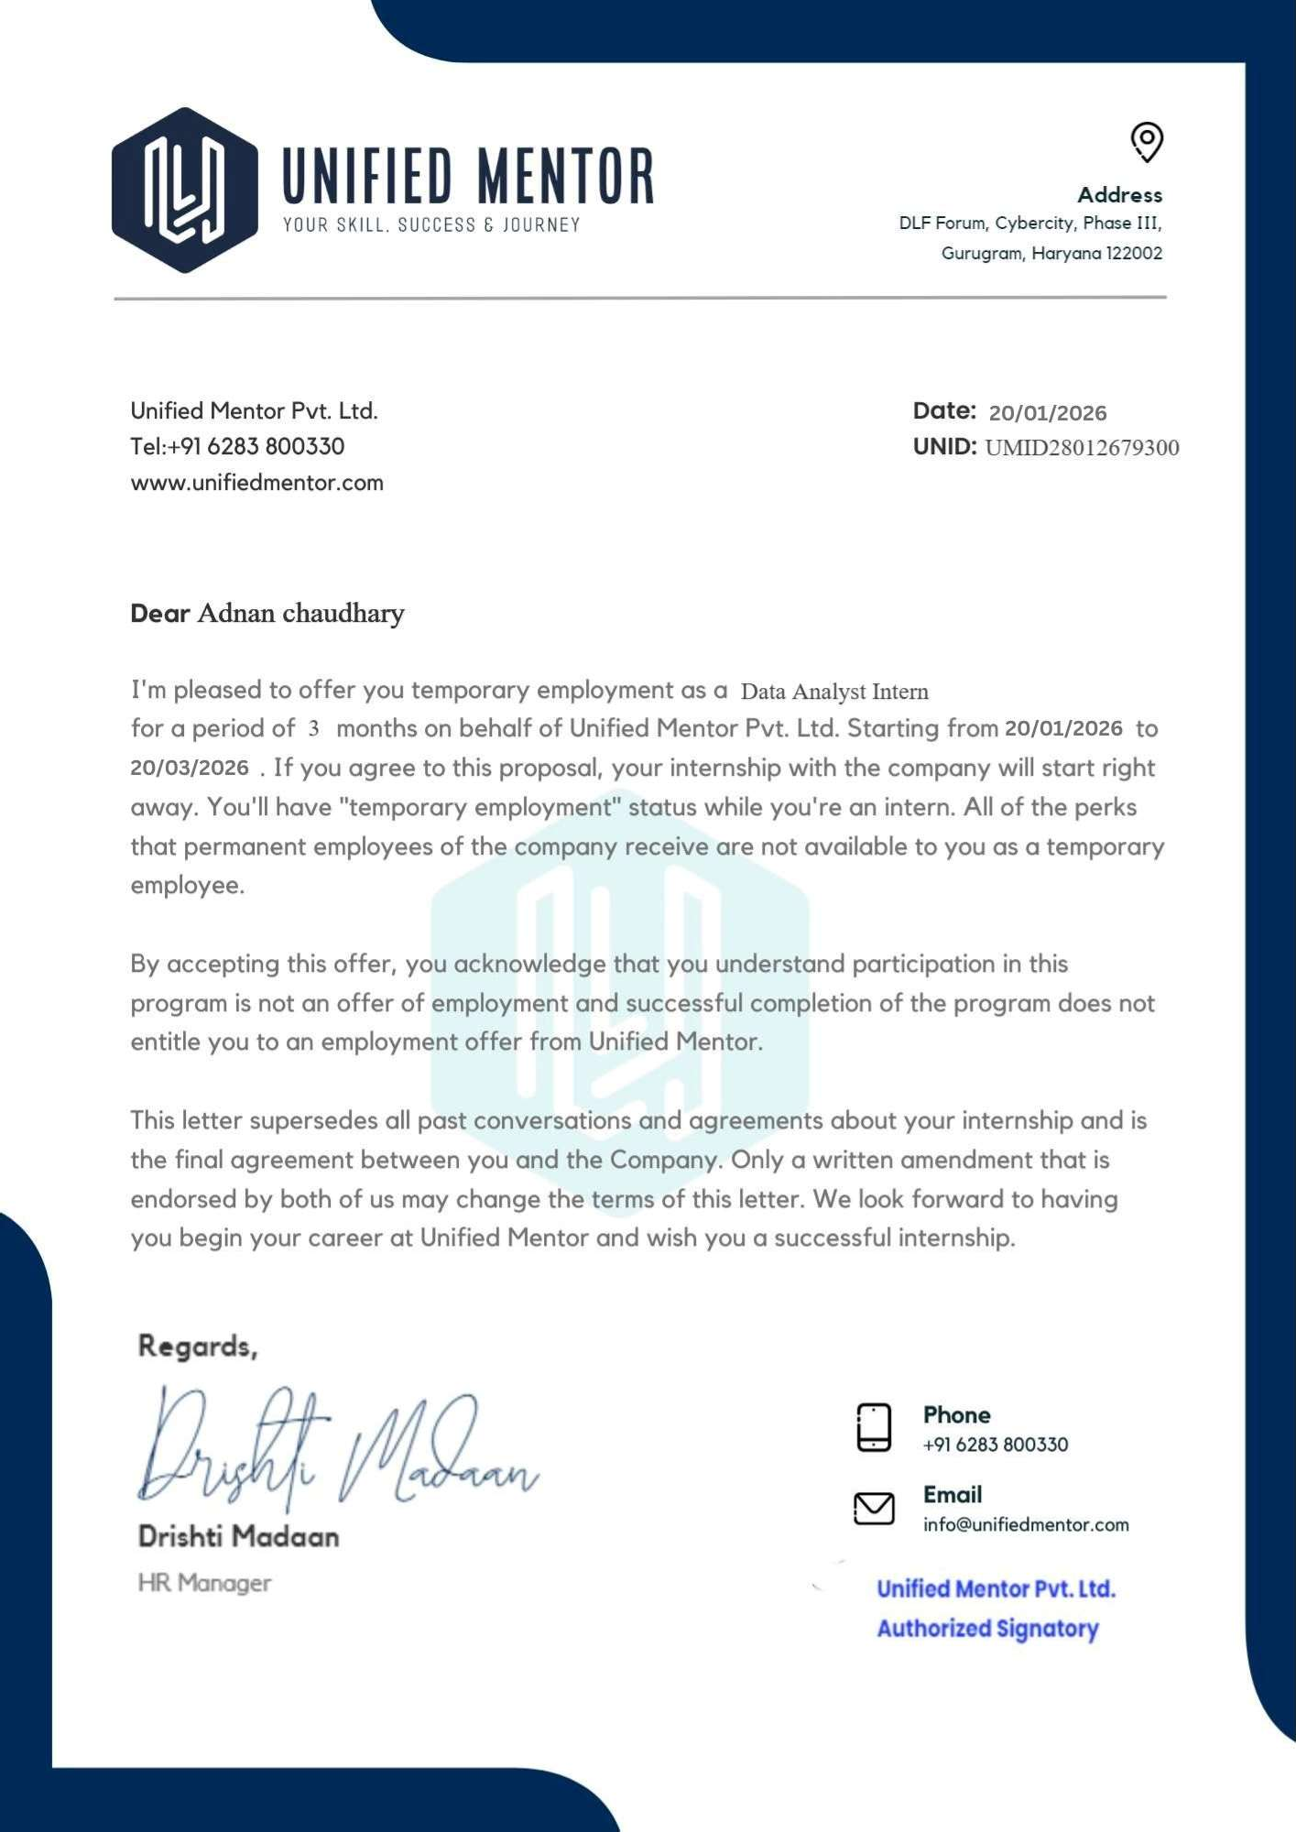

ABOUT ORGANIZATION
About Organization – Unified Mentor
Unified Mentor is a professional training and mentorship platform focused on bridging the gap between academic learning and industry requirements. The organization provides students and fresh graduates with practical exposure through internships, live projects, and skill-based training programs.

Unified Mentor offers training in various domains such as Data Science, Machine Learning, Web Development, Digital Marketing, and Business Analytics. Their programs are designed to enhance technical knowledge as well as improve problem-solving and real-world application skills.
The organization emphasizes hands-on learning by providing project-based assignments, guidance from experienced mentors, and industry-relevant tools and technologies. This approach helps students build strong portfolios and gain confidence to work in professional environments.

Unified Mentor also supports career development by offering certification programs, resume- building assistance, and interview preparation guidance. Through its structured training modules, the organization aims to make students job-ready and aligned with current industry standards.

During my association with Unified Mentor, I gained valuable insights into practical implementation of concepts, improved my technical skills, and understood the workflow of real-world projects under expert supervision.
LinkedIn: (22) Unified Mentor: Overview | LinkedIn

OJT UNDERTAKING

Student Name | Adnan Choudhary
Current Address | Room no.1 Mustaq Chawl Jari Mari Sakinaka Kurla Andheri Road  Near Ayesha Banquet Mumbai 400072
Residence Address | Room no.1 Mustaq Chawl Jari Mari Sakinaka Kurla Andheri Road  Near Ayesha Banquet Mumbai 400072
Email ID | Chaudharyadnan9075@gmail.com
Mobile No | 8451963116
Aadhar Card | 932754980076
PAN Card
Overall GPA
Mode of Internship | Online
I confirm that I agree with the terms, conditions, and requirements of the OJT Policy.

Student Signature Date :
I confirm that the student has attended the OJT orientation, and he has met all paperwork and process requirements to participate in the OJT programme and has received approval from his mentor.

Coordinator

Date :

PROGRESS REPORT FOR THE MONTH OF JANUARY 2026
Organization Name | Date of Report | Student Signature
 | 20/01/2026
Name of Student | Adnan Choudhary
Reporting Person Name and Designation | Kapil Singh, leading career and employee counselling
Reporting Person’s Contact Details | 9289191666
Job Description and Responsibilities | During my internship at Unified Mentor, I worked as a Data Analyst/IT Intern where I handled data preprocessing, analysis, and basic machine learning tasks. I developed regression models, created visualizations, and built simple APIs and user interfaces using tools like Python, FastAPI, and Streamlit. I also documented my work and  collaborated with mentors to complete projects efficiently.
Technology Used during Internship | Python Pandas NumPy Matplotlib Google Colab
Overall Learning Experiences | Learning Experience | I improved my skills in Python, data  preprocessing, and visualization techniques.
 | Skills Learnt | - Data Analysis  - Data Cleaning  - Python Programming
 | Knowledge Acquired | - Understanding of data analysis workflow  - Knowledge of data preprocessing techniques
Personal SWOC Analysis during Internship | Strength | - Quick learner  - Strong analytical thinking  - Good problem-solving skills
 | Weakness | - Sometimes overthink solutions  - Limited real-world experience (improving through practice)  - Time management needs improvement in complex tasks  - Tendency to focus too much on perfection
 | Opportunities | Gained hands-on experience with real-world projects
 | Challenges | Debugging errors in code and models

MONTHLY REPORT

PROGRESS REPORT FOR THE MONTH OF FEBRUARY 2026
Organization Name | Date of Report | Student Signature
 | 25/02/2026
Name of Student | Adnan Choudhary
Reporting Person Name and Designation | Kapil Singh, leading career and employee counselling
Reporting Person’s Contact Details | 9289191666
Job Description and Responsibilities | During my internship at Unified Mentor, I worked as a Data Analyst/IT Intern where I handled data preprocessing, analysis, and basic machine learning tasks. I developed regression models, created visualizations, and built simple APIs and user interfaces using tools like Python, FastAPI, and Streamlit. I also documented my work and  collaborated with mentors to complete projects efficiently.
Technology Used during Internship | Python Pandas NumPy Matplotlib FastAPI Streamlit  Jupyter Notebook / Google Colab
Overall Learning Experiences | Learning Experience | I also learned how to develop APIs and build interactive dashboards.
 | Skills Learnt | - Dashboard Development  - Problem Solving  - Analytical Thinking
 | Knowledge Acquired | - Basics of data visualization techniques  - Insight into industry-level project development
Personal SWOC Analysis during Internship | Strength | - Adaptable to new technologies  - Ability to work independently and in a team
 | Weakness | Time management needs improvement in complex tasks
 | Opportunities | Exposure to industry-level tools and technologies
 | Challenges | • Managing time while learning new technologies  • Applying theoretical concepts to practical  problems

MONTHLY REPORT

PROGRESS REPORT FOR THE MONTH OF MARCH 2026
Organization Name | Date of Report | Student Signature
 | 22/03/2026
Name of Student | Adnan Choudhary
Reporting Person Name and Designation | Kapil Singh, leading career and employee counselling
Reporting Person’s Contact Details | 9289191666
Job Description and Responsibilities | During my internship at Unified Mentor, I worked as a Data Analyst/IT Intern where I handled data preprocessing, analysis, and basic machine learning tasks. I developed regression models, created visualizations, and built simple APIs and user interfaces using tools like Python, FastAPI, and Streamlit. I also documented my work and  collaborated with mentors to complete projects efficiently.
Technology Used during Internship | Python Pandas NumPy Matplotlib FastAPI Streamlit  Jupyter Notebook / Google Colab
Overall Learning Experiences | Learning Experience | I also learned how to develop APIs and build interactive dashboards.
 | Skills Learnt | - Machine Learning(Basic)  - Report Writing  - Project Deployment
 | Knowledge Acquired | - Basics of machine learning and regression models  - Working with real-world datasets  - Understanding of API integration and deployment
Personal SWOC Analysis during Internship | Strength | - Quick learner  - Strong analytical thinking  - Good problem-solving skills  - Adaptable to new technologies  - Ability to work independently and in a team
 | Weakness | Tendency to focus too much on perfection
 | Opportunities | • Gained hands-on experience with real-world projects  • Exposure to industry-level tools and technologies  • Improved technical and analytical skills  • Guidance from experienced mentors  • Enhanced career readiness and confidence
 | Challenges | Adapting to project requirements and deadlines

ATTENDANCE SHEET

Name & Address of Organization Unified Mentor.
Cyber City, WeWork DLF Forum, DLF Phase 3, Gurugram, Haryana 122002
Name of the Student |  |  |  | Adnan Choudhary
Roll Number |  |  |  | 20
Name of Course |  |  |  | MSC IT Part I
Date of Commencement of Training |  |  |  | January 2026
Date of Completion of Training |  |  |  | March 2026
Week | Monday | Tuesday | Wednesday |  | Thursday | Friday | Saturday
1 | 02-12-2025 | 03-12-2025 | 04-12-2025 |  | 05-12-2025 | 06-12-2025 | 07-12-2025
 | (Sign) | (Sign) | (Sign) |  | (Sign) | (Sign) | (Sign)
2 | 09-12-2025 | 10-12-2025 | 11-12-2025 |  | 12-12-2025 | 13-12-2025 | 14-12-2025
 | (Sign) | (Sign) | (Sign) |  | (Sign) | (Sign) | (Sign)
3 | 16-12-2025 | 17-12-2025 | 18-12-2025 |  | 19-12-2025 | 20-12-2025 | 21-12-2025
 | (Sign) | (Sign) | (Sign) |  | (Sign) | (Sign) | (Sign)
4 | 23-12-2025 | 24-12-2025
 | (Sign) | (Sign)
5
6
7
8
9
10
11
12

COMPLETION CERTIFICATE

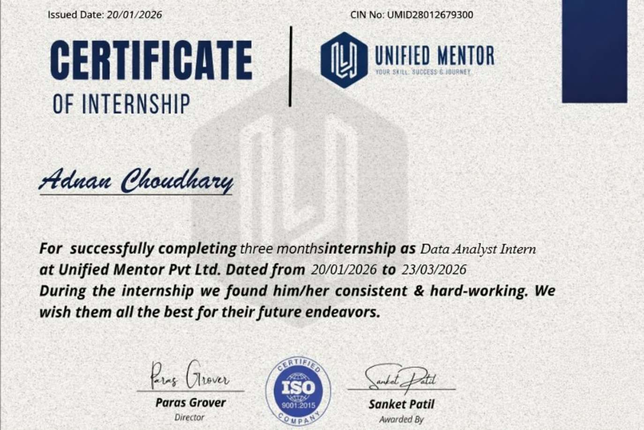

STUDENT FEEDBACK OF OJT

Student Name: Adnan Choudhary Date :
Organization Supervisor : : Kapil Singh Title : : Team Leader Supervisor Email : kapil.singh@unifiedmentor.com OJT is : ⬜ Unpaid ⬜ Paid Organization : Unified Mentor
Organization Address : Cyber City, WeWork DLF Forum, DLF Phase 3, Gurugram, Haryana 122002

Faculty Coordinator : Department : Information Technology

Dates of OJT : From : 20/01/2026 To : 23/03/2026

Give a brief description of your OJT work (title and tasks for which you were responsible) :
Was your internship experience related to your major area of study ?
⬜ Yes, to a large degree.
⬜ Yes, to a slight degree.
⬜ No, not related at all.

Indicate the degree to which you agree or disagree with the following statements.

This experience has | Strongly Agree | Agree | Neutral | Disagree | Strongly Disagree
Given me the opportunity to explore a career field
Allowed me to apply classroom theory to practice
Helped me develop my decisionmaking and problem-solving skills.
Expanded my knowledge about the work world before permanent employment.
Helped me develop my written and oral communication skills
Provided a chance to use leadership skills (influence others, develop ideas with others, simulate decisionmaking and action)

This experience has | Strongly Agree | Agree | Neutral | Disagree | Strongly Disagree
Expanded my sensitivity to the
ethical implications of the work involved
Made it possible for me to be
more confident in new situations
Expanded my sensitivity to the ethical implications of the work involved
Made it possible for me to be
more confident in new situations
Given me a chance to improve
my interpersonal skills
Helped me learn to handle responsibility and use my time wisely
Helped me discover new aspects of myself that I didn’t know
existed before
Helped me develop new interest
and abilities
Helped me clarify my career goals
Provided me with contacts which may lead to future employment
Allowed me to acquire information and/or use equipment not available at my
Institute

In the Institute OJT program, faculty members are expected to be mentors for students. Do you feel that your faculty coordinator served such a function? Why or why not?
The faculty coordinator provided basic guidance during the OJT program, such as monitoring progress and offering general instructions. However, the mentorship was moderate, as most of the learning and problem-solving was done independently. While support was available when required, more regular interaction and detailed feedback could have enhanced the overall learning experience. Nevertheless, the guidance provided helped in successfully completing the training.

How well were you able to accomplish the initial goals, tasks and new skills that were set down in your learning contract? In what ways were you able to take a new direction or expand beyond your contract? Why were some goals not accomplished adequately?
I was able to accomplish most of the initial goals and tasks outlined in my learning contract. I successfully applied concepts such as data cleaning, analysis, and basic machine learning model development in practical projects. I also gained hands-on experience with tools like Python, FastAPI, and Streamlit, which helped me build a strong foundation in real-world applications.

In what areas did you most develop and improve?
During my OJT, I showed significant improvement in data analysis and problem-solving skills. I developed a better understanding of data cleaning, visualization, and building machine learning models. I also improved my technical skills in tools like Python, FastAPI, and Streamlit. Additionally, my ability to work independently, manage time effectively, and approach real-world problems with a practical mindset improved considerably.
What has been the most significant accomplishment or satisfying moment of your OJT? The most significant accomplishment during my OJT was successfully completing my project and seeing it work as intended. Building a machine learning model and integrating it with an API and user interface was a very satisfying experience, as it allowed me to apply theoretical knowledge in a practical way. It was especially rewarding to see the final output working smoothly, which boosted my confidence and gave me a sense of achievement.

What did you dislike about the OJT?
One aspect I disliked about the OJT was the limited level of continuous mentorship and interaction, which sometimes made it challenging to get immediate guidance on complex topics. Additionally, certain tasks required extensive self-learning without structured support, which could be time- consuming. However, this also helped me become more independent and improve my problem- solving abilities.

Considering your overall experience, how would you rate this OJT? (Circle one).
Satisfactory / Good / Excellent

Give suggestions as to how your OJT experience could have been improved. (Could you have handled added responsibility? Would you have liked more discussions with your professor concerning your OJT? Was closer supervision needed? Was more of an orientation required?)
The OJT experience could have been improved with more regular guidance and discussions with the faculty coordinator, along with a clearer initial orientation. Timely feedback and slightly closer supervision would have enhanced learning. I also feel I could have handled additional responsibilities to gain more practical experience.

(Student Signature)
Name:Adnan Choudhary Roll No: 20

Date :

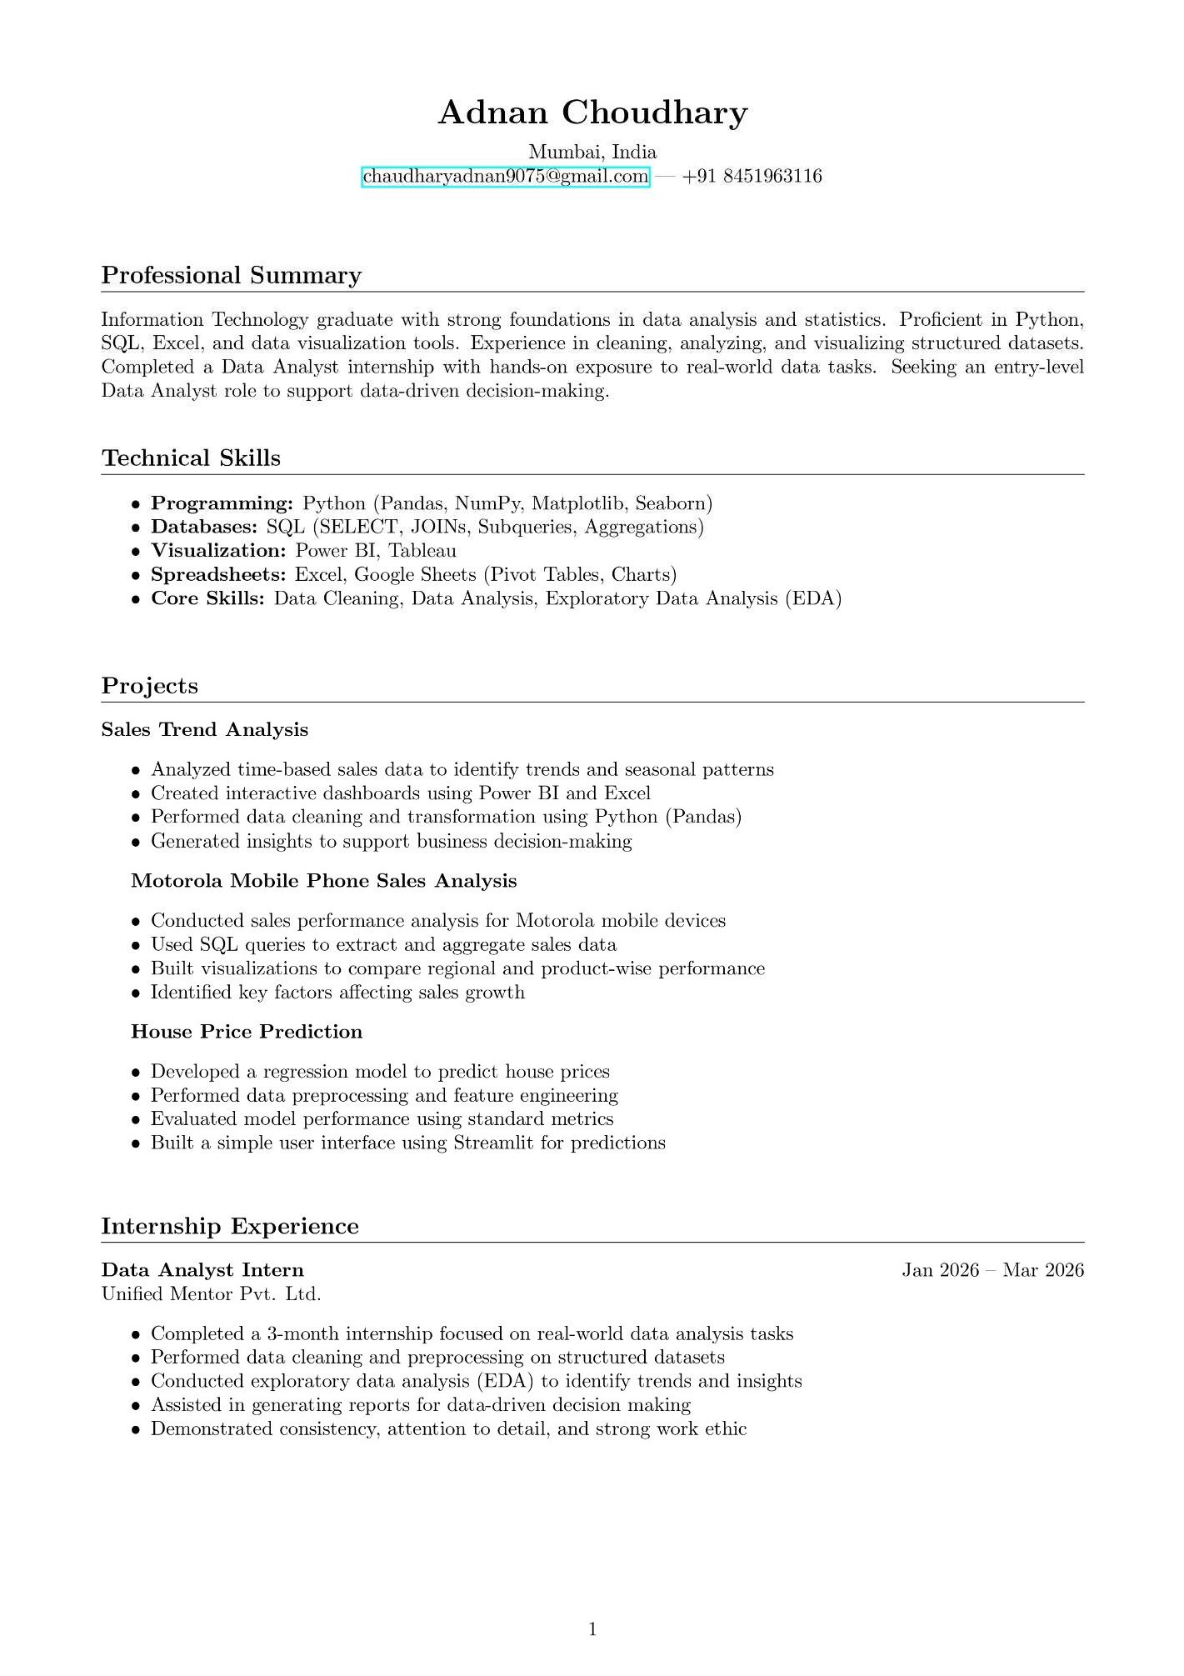
RESUME

